1. What is Apache Kafka?
Apache Kafka is a distributed event streaming platform used to build real-time data pipelines and streaming applications.
It enables:
- Publishing and subscribing to streams of records (like a message queue).
- Storing streams of records durably and reliably.
- Processing streams in real time or later (replayable history).

Kafka is used by giants like LinkedIn (who created it), Uber, Netflix, and Spotify for mission-critical workloads.
Example Use Case:
A payment service publishes "TransactionCompleted" events to Kafka.
- Analytics service consumes it to update real-time dashboards.
- Email service listens to the same topic to send receipts.
- Fraud detection module listens to same topic to scan patterns.

Kafka acts like a real-time event bus.

🔷 Key Features
Feature | Description
Scalable | Add brokers to grow; partitions allow parallelism
Durable | Uses disk-based storage and replication
Replayable | Consumers can rewind or replay data
Fast | Millions of messages/sec throughput
Decoupled | Loose coupling between producer and consumer

🔷 What Does a “Stream” Mean?
A stream is a continuous flow of data:
- Events like "user_logged_in", "order_placed", "sensor_reading"
- Data is typically small and frequent, not bulk
- Ordered and timestamped
- Often modeled as an infinite series of records

🔷 What are Events in Streaming?
An event = one record in a stream.
It usually includes:
- Key (optional): e.g., CustomerId = 123
- Value (required): e.g., { OrderId: 678, Amount: 50.0 }
- Timestamp: When event occurred
- Kafka stores all events in order per partition

Commands
Create Topic
kafka-topics --create --topic orders --bootstrap-server localhost:9092 --partitions 3 --replication-factor 1

To list all topics
kafka-topics --list --bootstrap-server localhost:9092

Describe Topic Details
kafka-topics --describe --topic orders --bootstrap-server localhost:9092

CLI Console Producer to send a message for testing
kafka-console-producer --topic orders --bootstrap-server localhost:9092

CLI Console Consumer to read a message for testing
kafka-console-consumer --topic orders --bootstrap-server localhost:9092 --from-beginning --property print.partition=true --property print.offset=true

2: Core Kafka Components
Apache Kafka is made up of several key components that work together to enable scalable, reliable, real-time streaming.
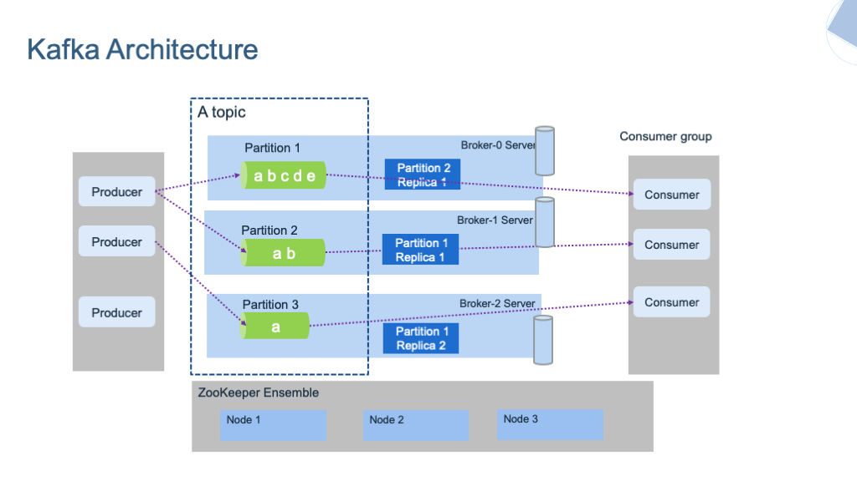
🧩 The Key Components
Component | Role
Topic | A named stream/channel of messages
Partition | A scalable unit inside a topic
Broker | A Kafka server that stores data
Producer | Sends (writes) data to Kafka
Consumer | Reads (subscribes to) data from Kafka
Consumer Group | A way to scale out consumers

🟩 1. Topic
- A logical channel or feed name to which messages are published.
- Topics are just a logical name to organize messages.
- Topics are durable: messages can be retained on disk not memory for hours/days/weeks.
- Multiple consumers can read the same topic independently.
- Topics are split into partitions.
- One topic = one type of event (Recommended / Best Practice)
Event | Topic
Order placed | orders
Payment processed | payments
Shipment created | shipments
💡 You can put multiple event types in one topic, but it’s not recommended unless they are very closely related and always processed together.

🟨 2. Partition
- A partition is like a log file on disk — an append-only sequence of messages.
- Each partition stores messages in ordered, immutable log of messages.
  - New messages are appended at the end of the partition.
  - Each message has a unique offset (starting from 0).
    - Each offset is just a pointer — like a line number.
- Allows parallelism: consumers can read in parallel.
- Each topic partition is a commit log.
📘Commit Log
A commit log (also called an append-only log) is a persistent, ordered, immutable sequence of records.
🔍 Key properties:
Property | Meaning
Append-only | New records are only added at the end
Ordered | Events are strictly ordered (by offset)
Immutable | Once written, data is never modified
Durable | Records are stored on disk

📁 Kafka Partition Folder Structure:
🧾 1. .log File → Actual Messages (00000000000000000000.log)
This file contains the raw Kafka messages in binary format (key, value, headers, timestamp, etc.).
- Appended to as new records are produced
- Immutable (Kafka never edits it)

📌 2. .index File → Offset → File Position Mapping
This is a sparse index that maps logical offsets to byte positions inside the .log file.
- To avoid reading the entire log file to find offset 357.
- Helps Kafka quickly jump to a record with a certain offset
- Used when consumer seeks to a specific offset.
🕒 3. .timeindex File → Timestamp → File Position Mapping
- This maps timestamps to positions in the log file.
- To allow time-based lookups, like: “Start consuming from events after 10:30 AM”
- Consumer API seeks to seek(timestamp)
- Kafka handles time-based log retention
- Log compaction or delete operations depend on event age

📁 Kafka doesn't store all data for a partition in a single giant file — instead, it splits each partition's log into segments.
  - Avoid huge files that are slow to read/write
  - Allow efficient deletion (just delete entire segment file)
  - Make log compaction and retention more manageable
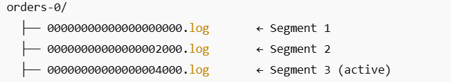

- Each .log file is a log segment
- Each segment starts with an offset in the file name
- The active segment is the one currently being written to
- When it exceeds a size or time limit, Kafka rolls over to a new segment

🔁 Segment Rolling (Rollover Conditions) rolls over to a new log segment when
Setting | Meaning | Default
segment.bytes | Max segment file size | 1 GB
segment.ms | Max time before rolling a new one | 7 days
segment.index.bytes | Max index size | 10 MB
These apply per partition, so a topic with 10 partitions = up to 10 active segment files

🔄Data Retention and Deletion
Kafka does not delete messages immediately after consumption.
It deletes them based on retention policy, not consumption:
⏱ Time-based: e.g., keep data for 7 days (retention.ms).
💾 Size-based: e.g., max topic size = 10GB (retention.bytes).
♻️ Log Compaction: keep only latest value for each key (more below).

🛠️ Retention Configuration Settings: (apply per topic, and even per partition)
Config | Type | Default | Meaning
retention.ms | Time | 7 days | How long to keep data
retention.bytes | Size | -1 (no limit) | Max size of log before deletion
cleanup.policy | String | delete | Use delete or compact

🧹 How Kafka Deletes Old Segments (delete policy)
- Kafka does not delete individual messages. Instead, Kafka’s LogCleaner background thread deletes entire segment files once they - are “expired.”

✅Conditions for Segment Deletion:
- Segment’s last message timestamp is older than retention.ms
- OR Total log size exceeds retention.bytes
If either is true, and the segment is not active, Kafka deletes it safely.

🧰 Access the Kafka container
docker exec -it kafka bash

🧪Create Topic with three partitions
kafka-topics --create --topic orders --bootstrap-server localhost:9092 --partitions 3 --replication-factor 1

📋List All Topics
kafka-topics --list --bootstrap-server localhost:9092

🔎Describe a Topic (Show Partition Info)
kafka-topics --describe --topic orders --bootstrap-server localhost:9092

🗑️ Set Retention Policy on Topic (only 1 minute)
kafka-configs --bootstrap-server localhost:9092 --entity-type topics --entity-name orders --alter --add-config retention.ms=60000

🔎Check Retention Policy Config on Topic
kafka-configs --bootstrap-server localhost:9092 --entity-type topics --entity-name orders –describe

📤CLI Console Producer to send a message for testing
kafka-console-producer --topic orders --bootstrap-server localhost:9092 --property "parse.key=true" --property "key.separator=:"

📥CLI Console Consumer to read a message for testing
kafka-console-consumer --topic orders --bootstrap-server localhost:9092 --from-beginning --property print.partition=true --property print.offset=true --property print.partition=true

📁View Segment Files (Inside Broker Filesystem)
ls /var/lib/kafka/data ls -lh /var/lib/kafka/data/orders-0/

🔥Delete a Topic
kafka-topics --bootstrap-server localhost:9092 --delete --topic orders
🟥 3. Broker
A Kafka server instance (Single Kafka Server).
It is responsible for:
Function | Description
Message Storage | Stores topic partitions on disk.
Message Routing | Receives messages from producers, routes/appends them to partitions.
Serving Consumers | Delivers messages to consumers with offset tracking.
Load Balancing | Handles partition leadership and distributes partitions across cluster
Coordination | Talks to ZooKeeper or KRaft (in new versions) to know cluster state

➡️ In a cluster, multiple brokers work together.
🔢 Each broker has a unique ID (e.g. broker.id=1).

📦 What Does a Broker Contain?
A Kafka broker:
- Stores data of one or more partitions in /var/lib/kafka/data/
- Handles partitions like orders-0, orders-1
- Keeps .log, .index, .timeindex files for each partition

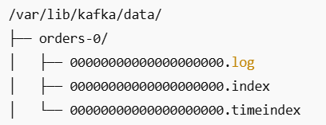

🎯 Key Concepts Around Brokers
- Each Broker Has an ID
- Set via broker.id in the config (e.g., broker.id=1) (Unique per broker).

- Topic Partitions Are Distributed
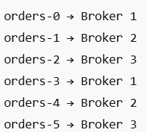
- A topic with 6 partitions might be spread across 3 brokers.
- Each broker handles a subset of the total partitions.

🔧 Broker Configuration Essentials
Here are some critical broker settings from server.properties:
Config | Meaning | Default
broker.id | Unique broker identifier | 0
log.dirs | Where to store partition files | /tmp/kafka-logs
num.network.threads | Threads for network I/O | 3
log.retention.ms | Message retention time | 7 days
log.segment.bytes | Max segment size | 1 GB
auto.create.topics.enable | Auto-create topics when accessed | true

🤝 What Is ZooKeeper?
ZooKeeper is Kafka’s external coordination system (used in Kafka 2.x and 3.x).
It is the brains for:
- Storing metadata (brokers, topics, configs, controller)
- Handling leader election
- Tracking broker status
- Managing topic and partition assignmen

Role | Description
Broker Discovery | Keeps track of which brokers are in the cluster
Controller Election | Decides which broker acts as Controller (manages partition leaders)
Configuration Store | Stores cluster metadata and configs
Quorum | Ensures consistency with consensus (uses ZAB protocol)

ZooKeeper helps Kafka stay consistent and fault-tolerant — it’s the brain of the cluster in pre-KRaft versions.

🧰 Access the Kafka container
docker exec -it kafka bash

🧱 List All Active Brokers
zookeeper-shell zookeeper:2181 <<< "ls /brokers/ids"

📄 Get Details of a Specific Broker
zookeeper-shell zookeeper:2181 <<< "get /brokers/ids/1"

👑 Find the Controller Broker
zookeeper-shell zookeeper:2181 <<< "get /controller"

🔍List Topics on a Broker
kafka-topics --bootstrap-server kafka:9092 --describe | grep "Leader: 1"

📜 Broker Config Verification
kafka-configs --bootstrap-server kafka:9092 --entity-type brokers --entity-name 1 –describe

🔧Alter Broker Config at Runtime
kafka-configs --bootstrap-server kafka:9092 --entity-type brokers --entity-name 1 --alter --add-config log.retention.hours=1

🧱 Kafka Cluster = Multiple Brokers + One ZooKeeper
What happens in a real Kafka cluster:
- ZooKeeper coordinates all brokers.
- Each broker has a unique broker.id.
- Topics are split into partitions, and partitions are distributed across brokers.
- You get replication, high availability, and failover.

✅ What’s Next?
You’re ready to move on to:
- Replication internals & ISR (in-sync replicas)
- Kafka Controller failover
- Deep broker metrics (like under-replicated-partitions)
- Topic-level configurations: compression, cleanup.policy
- Kafka without ZooKeeper (KRaft)

🟦 4. Producer
A producer is any client that sends (publishes) messages to Kafka topics.
🧠 Key Responsibilities:
- Connects to a Kafka broker.
- Publishes to a topic.
- Optionally assigns a partition or key.
- Handles acknowledgment (success/failure).

🧭 How the Producer Chooses a Partition
This lets you control message ordering (within a partition only).
Case | What Happens
No key, no partition | Kafka uses round-robin
With key | Kafka hashes the key → picks partition
Manual partition | Goes directly to that partition

🔹 What is the Partitioner?
When a producer sends a message, the partitioner decides which partition of the topic the message goes to.

The logic usually depends on:
- Explicit partition (you set it manually)
- Message key (hashed to choose partition deterministically)
- Default round-robin (if no key or partition specified)

✅ Option 1: Use a key
This uses a hash partitioner by default. Messages with the same key go to the same partition.
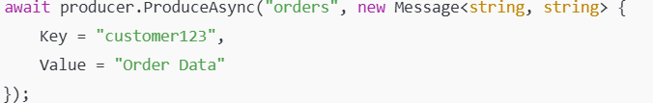

✅ Option 2: Specify partition directly
This overrides the default logic — you're now manually choosing the partition.
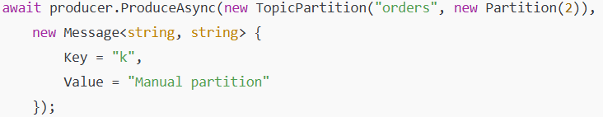

🎯 What is the RecordAccumulator?
- The RecordAccumulator is a buffering component inside the Kafka producer client.
- It accumulates (batches) messages per partition in memory before sending them to the Kafka broker.

🛠️ How It Works Internally
Here’s what happens when you call producer.Send(...):
- Partitioner decides which partition the record goes to.
- RecordAccumulator:
  - Looks up or creates a batch for that partition.
  - Appends the record to the in-memory batch.
- Background sender thread picks ready batches and sends them.

🔍 Key Configurations
Config Key | Meaning
batch.size | Max size (bytes) of a batch in memory for a single partition.
linger.ms | How long to wait before sending even if the batch isn't full.
buffer.memory | Total memory (across all partitions) available for buffering.
max.in.flight.requests.per  .connection | Controls how many batches can be sent in parallel before being acknowledged (important for ordering).

📌 Important Notes
✅ Accumulates per partition
- Each partition has its own queue.
- Allows per-partition ordering and batching.
✅ Works in background
- Sending is done by a background I/O thread.
- Your producer thread doesn't block unless memory is full.
✅ Key to performance tuning
- Kafka producer throughput is highly sensitive to:
  - batch.size
  - linger.ms
  - compression.type

🎯 What is acks?
The acks setting (short for acknowledgments) determines how many Kafka broker nodes must confirm a message before the producer considers it “successfully written.”

📐 Available acks Settings
Value | Meaning
0 | Fire-and-forget: no acknowledgment from broker. Fastest, but data may be lost.
1 | Wait for leader only to acknowledge. Safer than 0, but not fully durable if leader crashes before replicas sync.
-1 or all | Wait for all in-sync replicas (ISRs) to acknowledge. Strongest durability guarantee. Slower, but safest.

🔥 Important Interactions
🧠 1. With min.insync.replicas
- Even if acks=all, if not enough replicas are alive, the write will fail.
- min.insync.replicas ensures high durability.
- If only 1 replica is in sync → write fails.
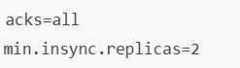
⚡ 2. With retries and idempotence
- If acks=all and retries > 0, messages will retry if a failure occurs.
- Without idempotence, retries can cause duplicate messages.
- With idempotence = true, Kafka guarantees no duplicates even after retries.

🗜️ Kafka Compression
Kafka producer can compress message batches before sending them to brokers.
This compression:
- Reduces the amount of data sent over the network
- Decreases disk usage on brokers
- Improves throughput, especially with larger payloads or high message volumes

🔑 The key point: Kafka compresses batches of records, not individual messages, to maximize efficiency.
Kafka brokers don’t recompress or decompress for internal storage — they just store the compressed payload as-is and send it compressed to consumers.
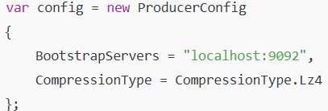

🧱 Compression Types (Codecs)
Type | Description
none | No compression (default in some clients)
gzip | High compression ratio, but CPU-intensive
snappy | Balanced — decent compression and fast speed
lz4 | Fast and efficient — good for real-time streams
zstd (Kafka 2.1+) | Highest compression ratio with lower CPU than gzip

🔁 Compression + Consumer Compatibility
- Consumers automatically decompress based on the compression codec set by the producer.
- No manual decompression is needed.
- Brokers don’t alter the compressed data, which allows end-to-end compression flow.

⚙️ Compression with Batching
Kafka achieves compression efficiency by:
- Accumulating multiple messages in RecordAccumulator
- Grouping them by topic + partition
- Compressing the entire batch
- Sending the compressed record set
The larger the batch, the more compression benefit you'll get.

💡Producer Idempotence
Idempotence means ensuring that a producer can send the same message multiple times — due to retries or failures — but the broker will write it only once to the topic-partition.

- Without idempotence: a retry due to network or broker timeout might result in duplicate messages.
- With idempotence: retries are deduplicated safely by the Kafka broker.

🎯 Goal of Idempotence
To guarantee:
- No duplicates even with retries
- Ordering is preserved within a partition
- Safe at-least-once delivery becomes exactly-once

⚙️ How Idempotence Works Internally
1. Producer ID (PID)
- Every idempotent producer gets a unique PID assigned by the Kafka cluster.
- This is stored server-side to identify that producer across retries.

2. Sequence Numbers (SeqNo) per Partition
- Every message sent to a partition includes an increasing sequence number.
- If a message with the same sequence number is received again (due to retry), it’s discarded.

3. Broker-side Deduplication
- The broker tracks the last sequence number per producer and partition.
- It drops duplicates, but still acks them to the producer — maintaining correctness.

✅ What Happens in Retry Scenarios?
Scenario | Without Idempotence | With Idempotence
Network failure after send | Retry causes duplicate | Retry causes deduplicated ack
Broker crash & retry | Message written twice | Message written once
Send timeout | Retry = duplicate | Retry = no duplicate

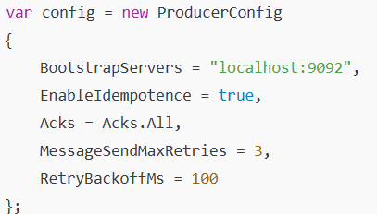

⚙️ How Retries Work Internally
Config | Purpose | Example
retries (C# MessageSendMaxRetries) | Max number of retries (not including original send) | 3
retry.backoff.ms | Wait time before next retry attempt | 100ms
🟧 5. Consumer
It’s a client that reads messages from one or more Kafka topics.
🎯 Responsibilities of a Consumer:
- Connect to the Kafka cluster
- Subscribe to topics
- Pull (poll) data from partitions
- Process messages
- Manage offset commits
- Handle failures and rebalancing (in groups).

🔹Core Characteristics of Consumers
Concept | Details
Pull Model | Kafka consumers poll the broker. Kafka never pushes.
Partition Ownership | Each partition is read by one consumer in a group. No two consumers in a group can read the same partition.
Offset Tracking | Consumers track their position in each partition via offsets (like bookmarks).
Offset Commit | Can be automatic or manual. Controls how Kafka knows what has been read.
Stateless | Consumers don’t store state; everything is tracked via offsets.

🔁 The life cycle:
  - Builds configuration context: bootstrap servers, group.id, deserializers, etc.

  - Connects to bootstrap broker(s).
    - It sends a MetadataRequest to any bootstrap broker and returns:
      - List of brokers.
      - Topic partitions count.
      - Leaders for each partition.
  - Initiates Group Coordination:
    - Sends JoinGroup request to Group Coordinator broker (determined via metadata).
      - group.id (e.g. "order-consumers").
      - subscribed topics list.
      - consumer capabilities.

  - Group Coordinator aggregates all active consumers:
    - Runs partition assignment strategy (e.g. range, round robin, sticky).
    - Decides which partitions go to which consumer.

  - Group Coordinator responds with JoinGroupResponse:
    - Partition assignments for this consumer.
    - Group generation id.
    - Member id.

🎯 Polling Life cycle
- The consumer uses poll() with a timeout parameter (e.g. 100ms, 500ms).
- Consumer sends a FetchRequest to the broker,
- The request remains open on the broker side until
  - New data arrives → responds immediately.
  - The timeout expires → responds with no data.
- The consumer code loop continues.
Consumer sends a request → Broker waits to respond until data or timeout

- The maximum delay between two consecutive poll() calls before the consumer is considered dead and removed from the group. max.poll.interval.ms
* If T1 - T0 > max.poll.interval.ms, broker considers this consumer as failed or stuck and triggers rebalance.

- poll(timeout): Controls how long the consumer waits for data on each call.

🟪 6. Consumer Group
A consumer group is a set of consumers that work together to consume data from a topic.
🔑 Key Points
- Each partition in a topic is consumed by only one consumer in the group at a time.
- Each consumer handles different partitions, improving throughput (parallelism).
- If different groups consume the same topic → each group receives all messages independently; Enables multiple independent processing applications.
- Rebalancing occurs when consumers join or leave.

🎯 Manages offsets
Offsets are managed at the consumer group level, but committed by the consumer.
- The broker stores offsets in the __consumer_offsets internal topic.
- Offsets are keyed by (consumer group id + topic + partition).
- The group coordinator broker manages them.

Offsets belong to the consumer group, not the individual consumer
- This is why if a different consumer with same group id starts, it picks up from last committed group offset.

🔄 Offset Commit Flow
  - Consumer reads messages (via poll()).
    - It processes the records.

  - Consumer commits offsets after processing.
    - If auto-commit is enabled (enable.auto.commit=true)
      - The consumer library periodically commits the latest polled offset automatically at the configured auto.commit.interval.ms.
    - If manual commit is used (enable.auto.commit=false)
      - The consumer calls commitSync() or commitAsync() explicitly after processing.

  - What happens during commit?
    - The consumer sends a CommitOffset request to the Group Coordinator (a broker elected for managing the group).
    - This updates the __consumer_offsets topic with the group id, topic, partition, and committed offset.

🔍 1. Kafka Consumer Architecture & Lifecycle
- Poll Loop (pull model, not push)
- Consumer Group, rebalance, partition assignment
- Deserialization, record handling, callback patterns
- Heartbeat, session timeout, auto commit vs manual commit

🧠 2. Offset Management
- Committed vs Current Offset
- Auto-commit vs Manual commit
- enable.auto.commit, commitSync() vs commitAsync()
- Storing offsets: Kafka topic vs external store (DB, Redis)

⚙️ 3. Configuration Deep Dive
- Key configs:
  - max.poll.records
  - fetch.min.bytes, fetch.max.wait.ms
  - session.timeout.ms and heartbeat.interval.ms
  - auto.offset.reset
- How they affect performance, latency, and rebalancing

🔁 4. Rebalancing Internals
- When and why rebalance happens
- What happens under the hood
- Strategies: RangeAssignor, RoundRobin, StickyAssignor
- Best practices to avoid "Rebalance Storm"

🛡 5. Fault Tolerance & Reliability
- Retrying & error handling
- Dead-letter topics (DLT)
- At most once / at least once / exactly once delivery guarantees
- Consumer resiliency patterns

🧪 6. Advanced Consumer Patterns
- Multi-threaded consumption (and why it's tricky)
- Backpressure handling
- Idempotent consumers
- Batch processing strategies
- Kafka Connect vs Custom Consumers

